Orbital Deep-UV Raman Spectroscopy for Asteroid Organic Detection:
A Feasibility Study with Quantum Enhancement Analysis
Sharahil Mahmud
Thomas Jefferson Highschool for Science and Technology

Abstract
This paper develops and evaluate a photon budget model for detecting organic compounds on asteroid (101955) Bennu via orbital deep-ultraviolet (DUV) resonance-enhanced Raman spectroscopy at 248 nm. The model is calibrated with OSIRIS-REx Visible and InfraRed Spectrometer (OVIRS) organic distribution maps and OSIRIS-REx Thermal Emission Spectrometer (OTES) surface temperature measurements, and evaluated across the full range of OSIRIS-REx mission phase distances (50–1600 m). At each distance, the model computes signal-to-noise ratios (SNR) for multiple organic concentrations, instrument configurations, and surface environment conditions. The analysis then applies the model to two problems. First, the analysis propagates parameter uncertainties through 10,000 Monte Carlo trials, identifying organic concentration as the dominant uncertainty driver (Spearman ρ = 0.79). Second, the analysis assesses whether quantum-enhanced detection — via squeezed-light injection or photon correlation analysis — could extend the detection envelope. Using both the analytical loss-degradation formula and QuTiP quantum state simulation, the analysis shows that squeezing is ineffective at the ~4.5% total optical efficiency characteristic of current space instrumentation, yielding only 0.18 dB effective noise reduction from 10 dB of ideal squeezing. A minimum efficiency of ~30% would be required for meaningful quantum advantage. Despite its heuristic nature, the photon budget model reliably identifies the feasibility boundary: detection is achievable during Reconnaissance (~375 m, SNR ≈ 11 for 5% organics) but marginal at Orbital B (~680 m, SNR ≈ 3.4). the paper discusses the advantages of DUV excitation, including its ~200× enhancement over visible Raman, and the applicability of this framework to other carbonaceous asteroid targets.
Keywords: Raman spectroscopy, asteroid Bennu, OSIRIS-REx, deep ultraviolet, organic detection, quantum sensing, photon budget, Monte Carlo

1. Introduction
The organic inventory of primitive asteroids constrains models of prebiotic chemistry and the exogenous delivery of life’s building blocks to early Earth (Lauretta & McSween, 2006; Pizzarello & Shock, 2010). Sample return from asteroid Bennu by OSIRIS-REx has revealed 4.0–4.7 wt% total carbon (Lauretta et al., 2024), 33 amino acids and all five nucleobases (Glavin et al., 2025), ribose (Furukawa et al., 2025), and nitrogen-rich polymeric organics formed by pre-aqueous cryochemistry (Sandford et al., 2025). Earlier remote-sensing observations by the OVIRS instrument detected widespread 3.4 μm organic absorptions across Bennu’s surface (Simon et al., 2020; Kaplan et al., 2021). These findings establish Bennu as one of the most organically rich bodies yet characterized.
Raman spectroscopy provides vibrational fingerprints that can distinguish mineral phases and organic functional groups with high molecular specificity (Long, 2002; Ferraro et al., 2003). Three Raman instruments now operate or are planned for planetary surfaces. The SHERLOC instrument on Mars Perseverance uses a 248.6 nm pulsed laser for DUV Raman and fluorescence mapping at 48 mm standoff (Bhartia et al., 2021), detecting minerals (Corpolongo et al., 2023) and organic-mineral associations (Sharma et al., 2023). SuperCam performs standoff Raman at 2–12 m using 532 nm excitation (Wiens et al., 2021; Maurice et al., 2021). The ExoMars RLS is a 532 nm contact instrument for the Rosalind Franklin rover (Rull et al., 2017). Terrestrial standoff Raman has been demonstrated at 430 m (Acosta-Maeda et al., 2016) and single-pulse daytime detection at 120 m (Misra et al., 2012).
However, no Raman measurement has been attempted at orbital distances — hundreds of meters to kilometers. While prior work has established Raman spectroscopy for planetary surfaces (Bhartia et al., 2021) and long-range terrestrial applications (Acosta-Maeda et al., 2016), the feasibility of performing such measurements from orbital altitudes at an extraterrestrial target has remained a theoretical assertion. Angel et al. (2012) noted the possibility but concluded it would require careful optimization, and no quantitative, data-driven assessment has followed. An “orbital gap” thus persists between the 48 mm standoff of SHERLOC and the hundreds-of-meters distances characteristic of asteroid proximity operations.
This work is motivated by a simple question: Can Raman spectroscopy detect organics on an asteroid from orbit?
Although Raman has been applied to returned asteroid samples — Hayabusa2-returned Ryugu particles were characterized via D and G band analysis (Bonal et al., 2024) — the possibility of performing such measurements remotely, from a spacecraft in proximity orbit, has not been quantitatively assessed. The OSIRIS-REx dataset provides an ideal testbed: the organic distribution, surface temperature, and albedo are all well-constrained by flight data, and the mission phase distances span the exact range of interest.

1.1 Contribution
It is emphasized that the goal of this work is not to propose a Raman instrument that outperforms existing compositional mapping techniques at orbital distances. Reflectance spectroscopy, as demonstrated by OVIRS and OTES, remains the most efficient approach for global-scale mapping. Rather, the interest in orbital Raman lies in its unique molecular specificity — the ability to distinguish individual organic species rather than bulk absorption features — and in the quantitative question of where the feasibility boundary lies.
A central element of this approach is the combination of a calibrated photon budget model with real OSIRIS-REx data. By calibrating with OVIRS-derived organic concentration maps (786,432 spatial records) and OTES surface temperatures, the calibration replaces key model assumptions with empirical measurements, providing the highest-fidelity assessment of orbital Raman feasibility to date. This data-driven calibration distinguishes the present work from purely theoretical models that rely on assumed target parameters. The analysis is then extended in two directions: Monte Carlo uncertainty quantification, which identifies the parameters that most strongly control detection feasibility, and quantum enhancement assessment, which evaluates whether squeezed light or photon correlation techniques could push the detection boundary to larger distances. The resulting systems-level framework connects instrument parameters, mission design, and target properties into a single cohesive model suitable for trade studies in future mission proposals. The insights gained from Bennu form a foundation for applying this framework to other carbonaceous asteroid targets.

1.2 Paper Organization
This paper is structured as follows. Section 2 introduces the photon budget model, its calibration, and the resulting structure of the detection problem. Section 3 presents the wavelength selection analysis. The model’s performance is evaluated in Section 4 across mission phases and in Section 5 via Monte Carlo uncertainty quantification. Quantum enhancement is assessed in Section 6 (squeezed light) and Section 7 (photon correlations). Additional discussion and concluding remarks are provided in Section 8. Technical details about the environment model and the Raman backscatter parameterization are provided in Appendices A and B.

2. Photon Budget Model

2.1 Signal Model
The detected Raman signal follows the pulsed lidar return equation adapted for surface-backscattered photons. For a pulsed laser system with pulse energy E_p, repetition rate f_rep, and integration time T, the number of detected signal photons is
N_signal = (E_p / E_photon) · K_R · Ω_tel · n_pulses · QE (1)
where E_photon = hc/λ is the laser photon energy, Ω_tel = A_tel/R² is the solid angle subtended by the telescope at range R, n_pulses = f_rep · T, and QE is the detector quantum efficiency. The Raman backscatter coefficient K_R (sr⁻¹ m⁻²) encapsulates the product of molecular cross-section, surface density, and sampling depth:
K_R = K_R^(1%,532) · (C_org/1%) · (532/λ)⁴ · f_res · f_env (2)
Here, K_R^(1%,532) = 10⁻¹¹ sr⁻¹ m⁻² is the baseline coefficient for 1% organics at 532 nm, the (532/λ)⁴ term captures the ν⁴ Raman scattering dependence (Asher, 1993), f_res is the resonance enhancement factor, and f_env accounts for surface environment effects. For 248 nm excitation, the wavelength scaling provides (532/248)⁴ ≈ 21.2×, and resonance enhancement of aromatic modes contributes f_res ≈ 10 below 260 nm (Abbey et al., 2017; Razzell Hollis et al., 2023; Gares et al., 2016). The total enhancement relative to 532 nm is therefore ~212×.

2.2 Background and Noise Model
Three background contributions enter the noise budget. Solar scattered background, reduced by pulsed time-gating with a 20 ns gate per pulse (duty cycle ~4 × 10⁻⁷), is computed as
N_solar = (F_solar · Δλ / E_photon) · (α/π) · A_spot · Ω_tel · Δt_gate · n_pulses · QE (3)
where F_solar ≈ 0.015 W m⁻² nm⁻¹ at 248 nm at Bennu’s heliocentric distance and α = 0.044 is Bennu’s geometric albedo (Li et al., 2021; Hamilton et al., 2019). Detector dark current scales as N_dark = 100 · exp((T_K − 300)/30) · T_int. Read noise contributes N_read = 25 · n_pulses.

2.3 Signal-to-Noise Ratio
The SNR follows shot-noise statistics:
SNR = N_signal / √(N_signal + N_solar + N_dark + N_read) (4)
the analysis adopts SNR ≥ 5 as the detection threshold, consistent with standard practice for unambiguous spectroscopic feature identification (Currie, 1999).

2.4 Calibration with OSIRIS-REx Data
The model is calibrated with three flight datasets. Surface organic concentrations are derived from 786,432 OVIRS spectral records of the 3.2–3.6 μm organic band area (Simon et al., 2020; Kaplan et al., 2021), scaled to weight percent, yielding concentrations of 1–15% across Bennu’s mapped surface. Surface temperatures are from OTES thermal emission measurements (Christensen et al., 2018), with a dayside range of 280–390 K. Solar spectral irradiance uses TSIS-1 data scaled to Bennu’s heliocentric distance.

2.5 Baseline Instrument Parameters
Table 1 lists the baseline instrument parameters used throughout this work. These are representative of a compact space-qualified DUV Raman lidar, informed by SHERLOC heritage (Bhartia et al., 2021) and terrestrial standoff systems (Acosta-Maeda et al., 2016; Misra et al., 2012).
Table 1
Baseline Instrument Parameters
Parameter | Symbol | Value
Excitation wavelength | λ | 248 nm (KrF excimer)
Pulse energy | E_p | 50 mJ
Repetition rate | f_rep | 20 Hz
Telescope aperture | D_tel | 30 cm
Detector QE | QE | 30%
Integration time | T | 10 s
Beam divergence | θ | 0.5 mrad
Gate width | Δt_gate | 20 ns/pulse
Dark current (300 K) | R_dark | 100 e⁻/s
Read noise | σ_read | 5 e⁻ rms

Table 2
SNR at OSIRIS-REx Mission Phase Distances (5% Organics, Baseline Instrument)
Mission Phase | Distance (m) | SNR | Feasibility
Sample Collection | 50 | 544.7 | Feasible
Reconnaissance | 375 | 11.3 | Feasible
Orbital B | 680 | 3.4 | Marginal
Detailed Survey | 750 | 2.8 | Not feasible
Orbital A | 1600 | 0.6 | Not feasible
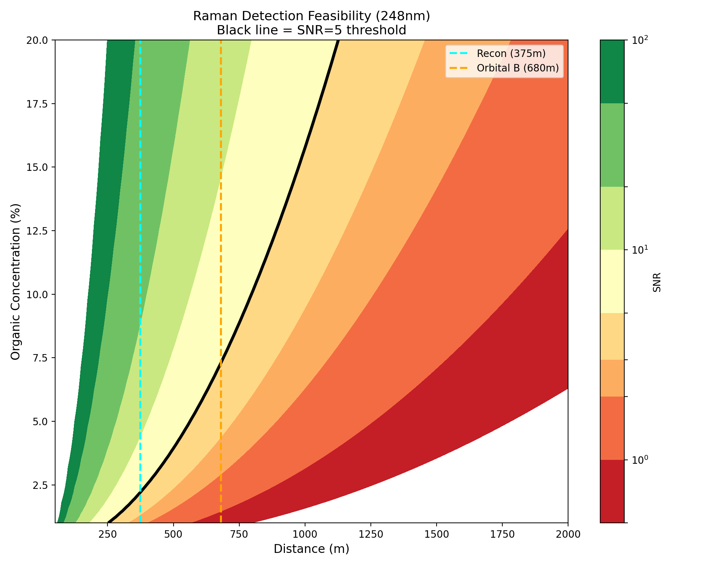[Figure 1 :fig1_feasibility_map.png]
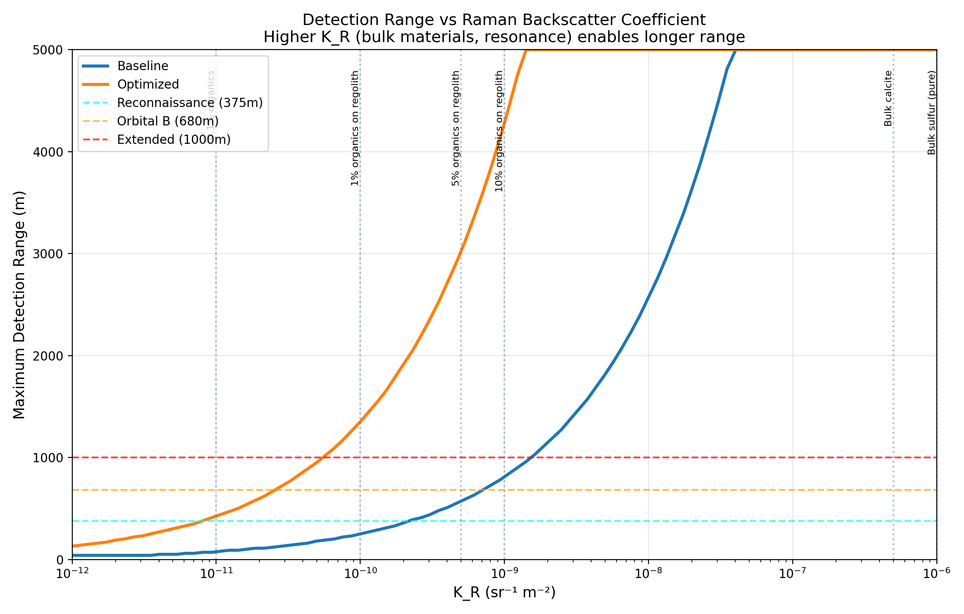
[Figure 2: fig1_K_R_requirements.png]

3. Wavelength Selection
The choice of excitation wavelength involves a trade-off between Raman signal enhancement, fluorescence interference, and background levels. the analysis compares four wavelengths: 532 nm (Nd:YAG second harmonic, 1× enhancement), 355 nm (third harmonic, ~10×), 266 nm (fourth harmonic, ~80×), and 248 nm (KrF excimer, ~212×). The enhancement factors combine ν⁴ scaling with wavelength-dependent resonance.
At 248 nm, two effects compound. First, (532/248)⁴ ≈ 21.2×. Second, excitation within the electronic absorption bands of aromatic organics provides resonance enhancement f_res ≈ 10 (Abbey et al., 2017; Razzell Hollis et al., 2023). The resonance selectively enhances the organics of interest — polycyclic aromatic hydrocarbons, kerogen, amino acids — while mineral backgrounds remain at normal Raman intensities.
An additional advantage is fluorescence avoidance. Below ~270 nm, the Raman spectral window lies entirely below the onset of fluorescence emission, eliminating the background that severely limits visible Raman on organic-rich samples (Gares et al., 2016; Uckert et al., 2021). SHERLOC operates at 248.6 nm for precisely this reason (Bhartia et al., 2021).
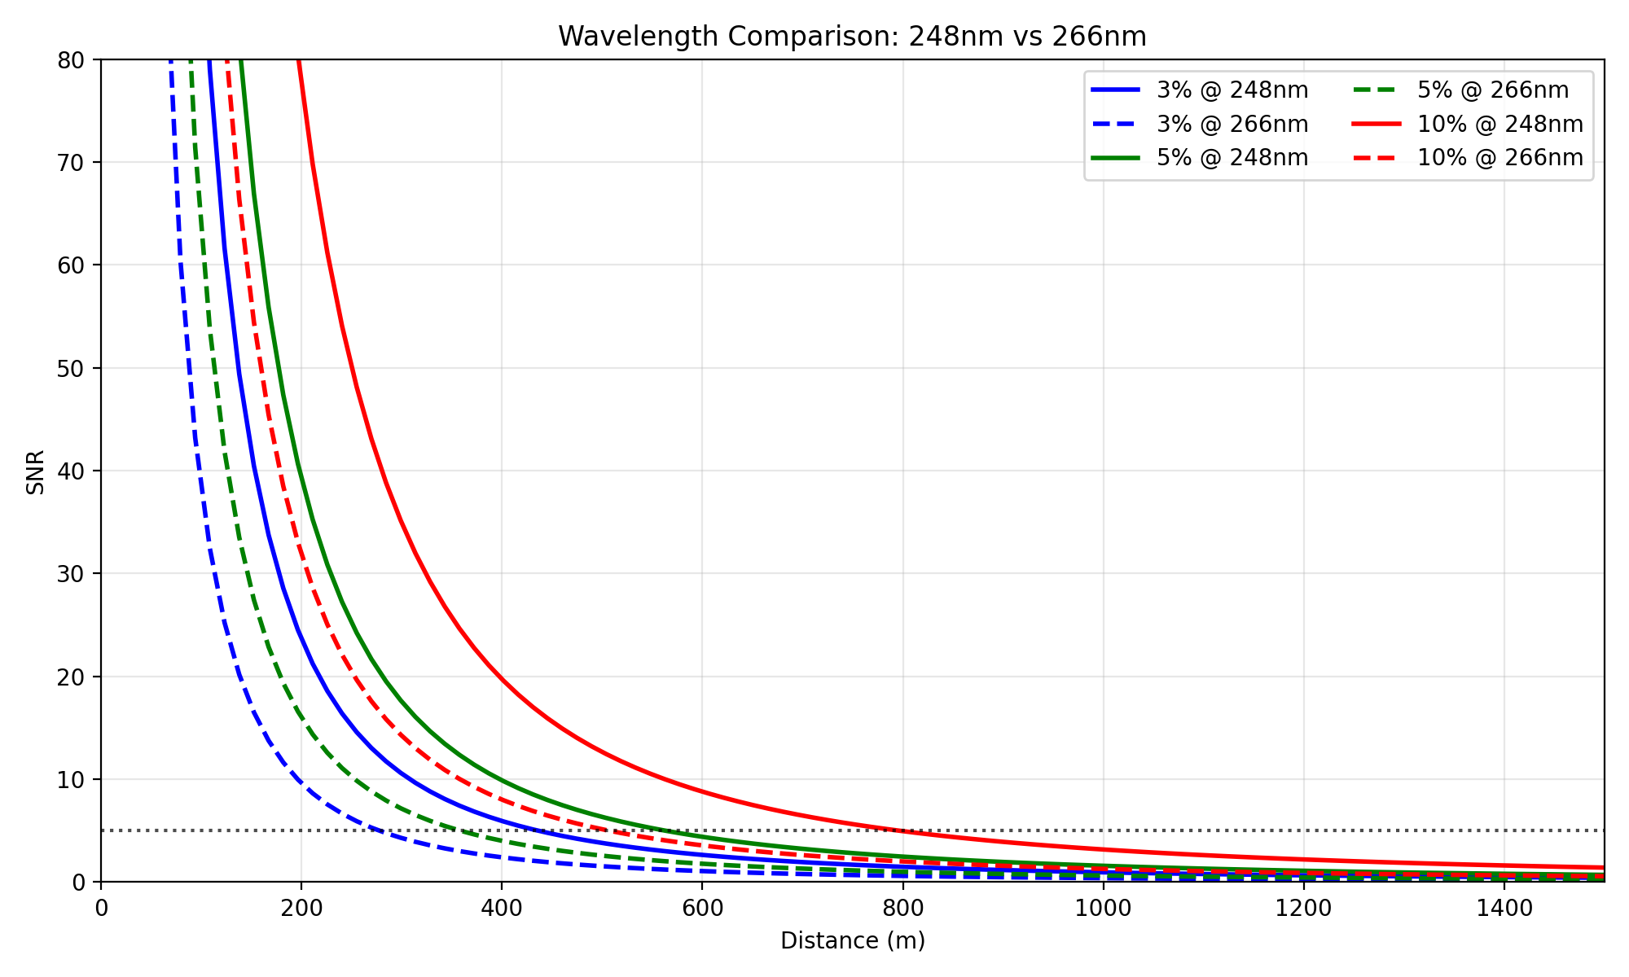[Figure 3: fig2_wavelength_comparison.png]
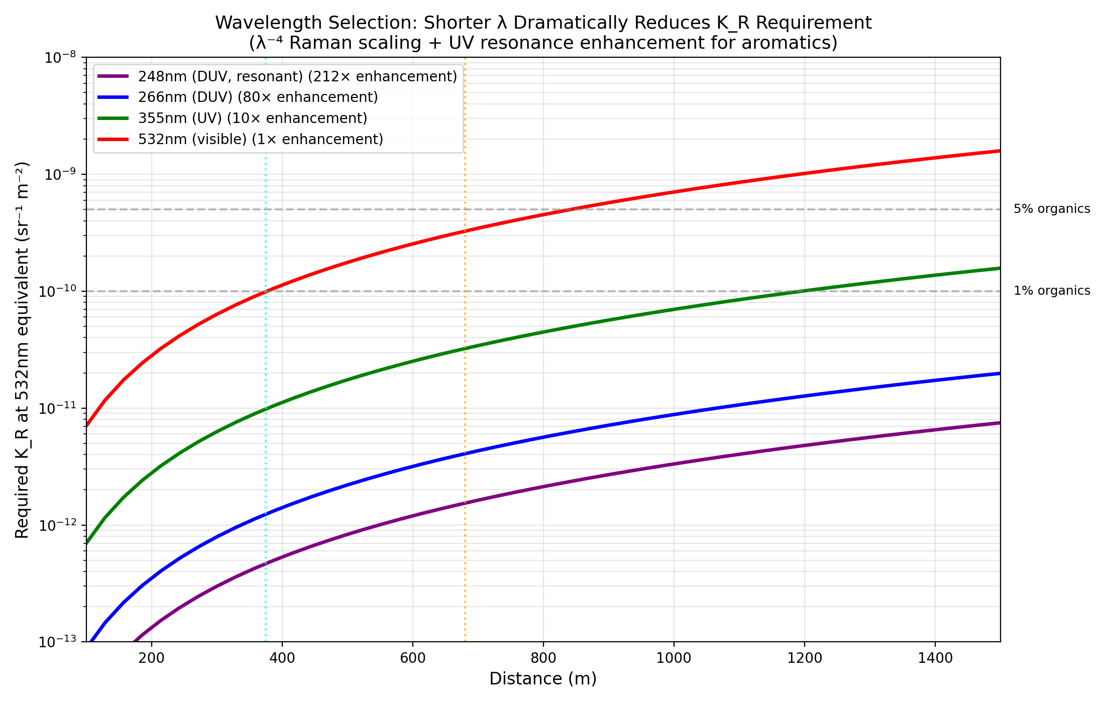[Figure 4: fig4_wavelength_effects.png]

4. Detection Feasibility

4.1 Mission Phase Matrix
this paper evaluates the photon budget at each OSIRIS-REx mission phase distance for five material scenarios spanning trace organics (K_R = 10⁻¹¹) to bulk minerals (K_R = 10⁻⁶). The matrix reveals a clear structure. At Sample Collection distance (50 m), every scenario above trace levels is comfortably detectable. At Reconnaissance (375 m), detection is feasible for organics at ≥ 3% concentration. Orbital B (680 m) marks the transition: only 10% organics or bulk minerals produce SNR ≥ 5.
[Figure 5: fig6_feasibility_matrix.png]
[Figure 6: fig6_mission_context.png]

4.2 Instrument Optimization
The three most impactful instrument parameters are pulse energy, telescope aperture, and integration time. The baseline configuration (50 mJ, 30 cm, 10 s) achieves detection at ~500 m. An optimized configuration (200 mJ, 50 cm, 60 s) extends this to ~1200 m, bringing Orbital B comfortably into range.
[Figure 7: fig3_parameter_sweep.png]

4.3 Realistic Surface Environment
Real surfaces introduce additional signal degradation from solar incidence angle (cosine loss), roughness (scattering), shadowing (signal zeroed), and dust accumulation. the study models these as a combined environment factor f_env following the statistical surface model described in Appendix A. This approach uses probability distributions for each degradation source rather than deterministic ray-tracing against Bennu’s detailed shape model. The choice is deliberate: for a mission-level feasibility study, the statistical model captures the expected range of surface conditions across thousands of potential pointing locations without the computational cost of simulating every specific boulder-shadow-incidence geometry.
At 375 m (Reconnaissance), the detectable surface fraction drops from 99.3% (ideal) to 56.2% (realistic). At 680 m (Orbital B), realistic coverage is approximately 1%.
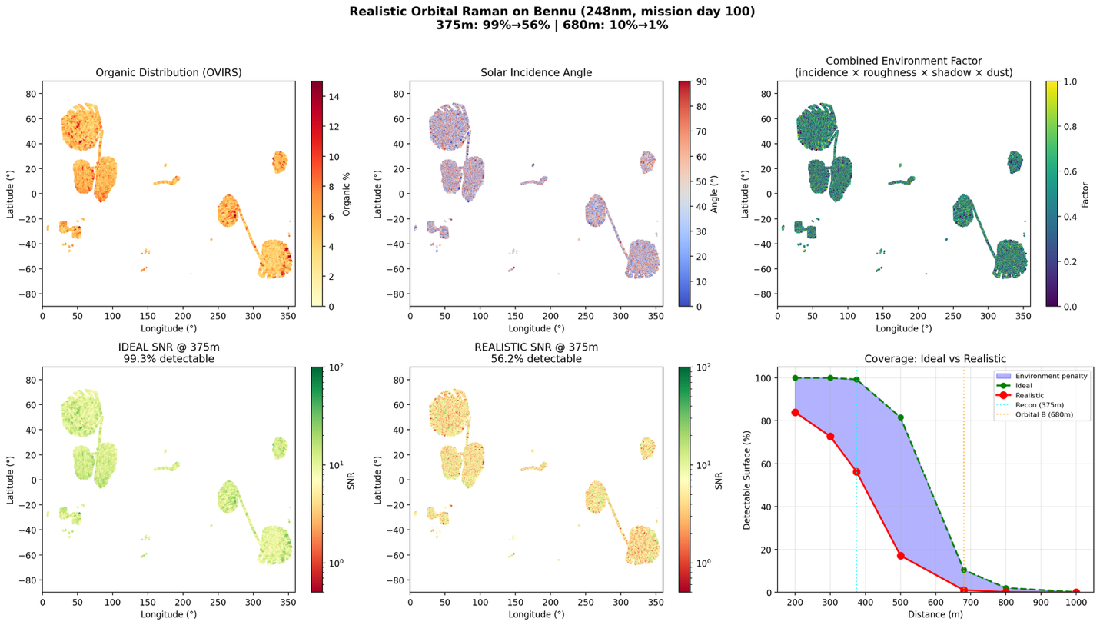[Figure 8: fig5_bennu_realistic.png]

4.4 Timing Jitter
For jitter values σ ≤ 100 ps, the 20 ns gate width is unaffected. Jitter is not a limiting factor for the proposed instrument.
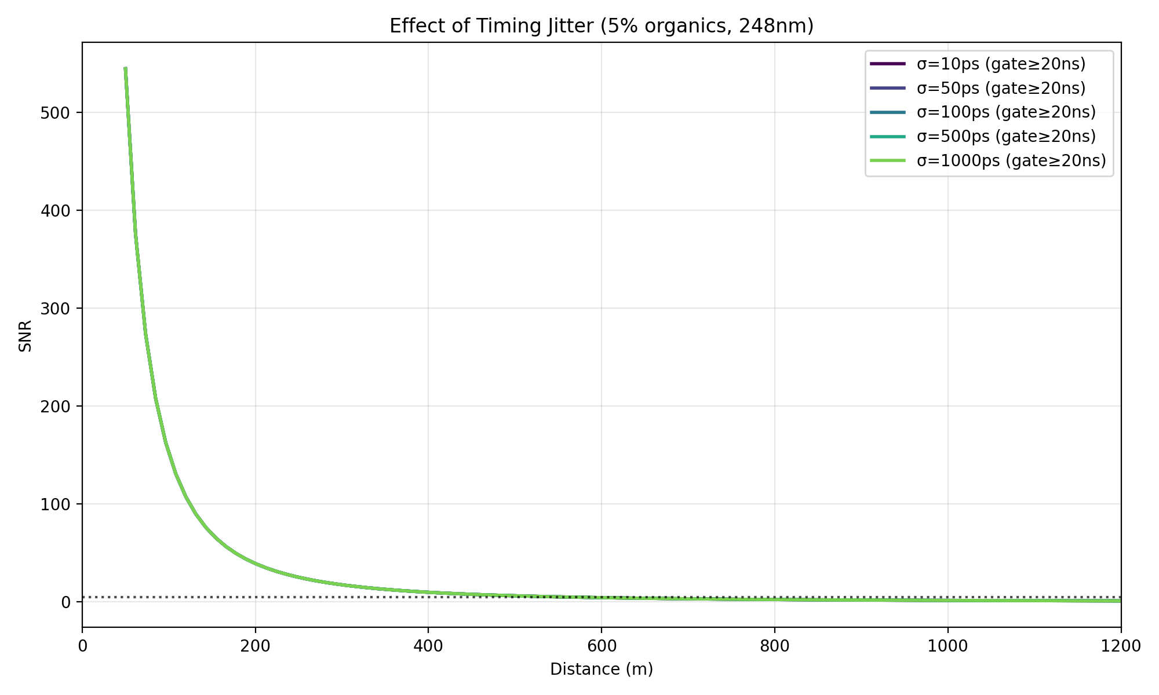[Figure 9: fig5_jitter_analysis.png]

5. Monte Carlo Uncertainty Quantification

5.1 Methodology
The analysis propagates parameter uncertainties through the full photon budget using 10,000 Monte Carlo trials (Thompson et al., 2020; Zhang & Shields, 2021). Seven parameters are sampled independently from uniform distributions: pulse energy (30–70 mJ), aperture (25–35 cm), integration time (8–12 s), surface temperature (280–350 K), solar irradiance (0.010–0.020 W m⁻² nm⁻¹), organic concentration (1–15%), and environment factor (0.3–1.0).

5.2 Results
At Orbital B distance (680 m), the MC analysis yields a median SNR of 3.1 with a 95% confidence interval of [0.5, 9.8]. The probability of achieving SNR ≥ 5 (detection) is 25.4%. The median maximum detection range is 523 m with a 95% CI of [199, 945] m.
Sensitivity analysis via Spearman rank correlation identifies organic concentration as the dominant driver of SNR uncertainty (ρ = 0.79), followed by the surface environment factor (ρ = 0.43) and pulse energy (ρ = 0.30). This finding has a clear practical implication: reducing uncertainty in the organic concentration and surface conditions of a target asteroid would do more to constrain mission feasibility than any reasonable improvement in instrument hardware.
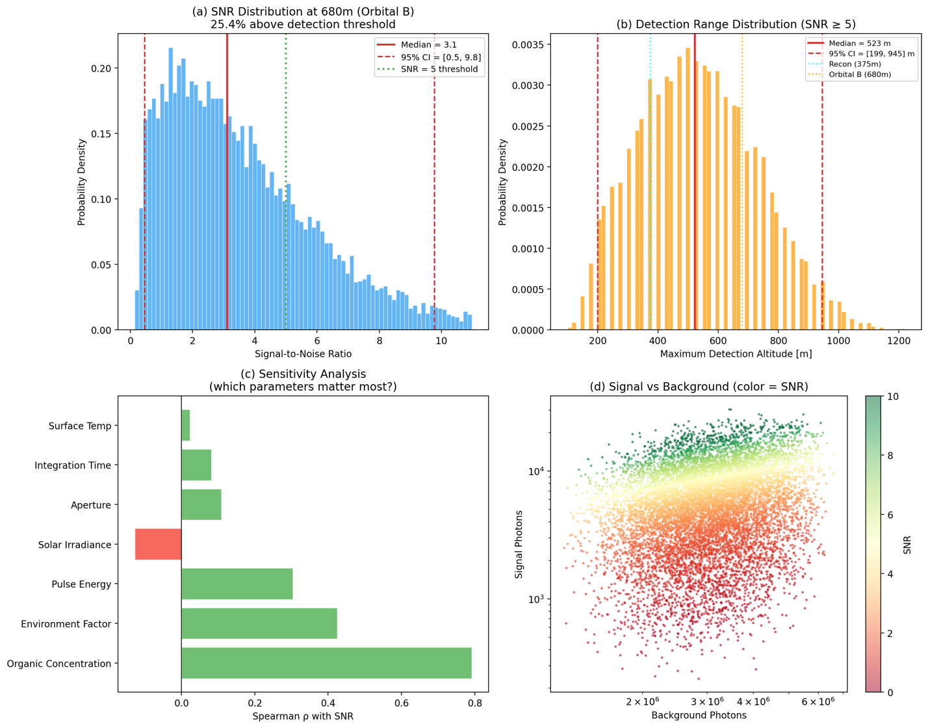[Figure 10: fig6_monte_carlo.png]

6. Quantum Enhancement via Squeezed Light

6.1 Motivation
Squeezed states of light reduce quantum noise below the shot-noise limit, providing sensitivity enhancement in gravitational wave detection (Tse et al., 2019), stimulated Raman spectroscopy (De Andrade et al., 2020), biological microscopy (Casacio et al., 2021), and dual-comb spectroscopy (Herman et al., 2025). However, these successes share a common feature: high optical efficiency in the detection chain, typically exceeding 50%. Whether quantum-enhanced sensing provides any advantage in the opposite regime — high-loss, photon-starved remote sensing — remains an open question. No published work has applied a rigorous quantum optics analysis to the specific problem of orbital Raman spectroscopy.

6.2 Loss-Degradation Analysis
When squeezed light with ideal noise variance V_ideal propagates through a channel with efficiency η, the effective variance is (Caves, 1981; Walls & Milburn, 2008):
V_eff = η · V_ideal + (1 − η) (5)
At η = 0.045 (4.5%), even perfect squeezing yields V_eff = 0.955, or 0.20 dB — negligible. With 10 dB ideal squeezing, V_eff = 0.9595. To gain ≥ 1 dB effective requires η > 20%; to match the 3 dB of LIGO (Tse et al., 2019) requires η > 50%.
the analysis verifies this result using QuTiP quantum state simulation. Squeezed vacuum states in a truncated Fock space (N = 40) are propagated through a beamsplitter loss model, and the output quadrature variance is computed. The numerical results agree with Equation (5) to within machine precision. This is consistent with the fundamental finding that loss bounds quantum advantage to a constant factor (Demkowicz-Dobrzański et al., 2012) and with the observation of Manceau et al. (2021) that squeezed states are ineffective when detection is inefficient.
the analysis identifies η ~ 30% as the threshold for meaningful advantage. This is not merely a negative result but a concrete technology development target. Reaching η ~ 30% in the deep UV would require next-generation UV-optimized single-photon detectors such as superconducting nanowire single-photon detectors (SNSPDs) and low-loss UV optical coatings. Until these technologies mature, classical instrument optimization remains the more productive path.
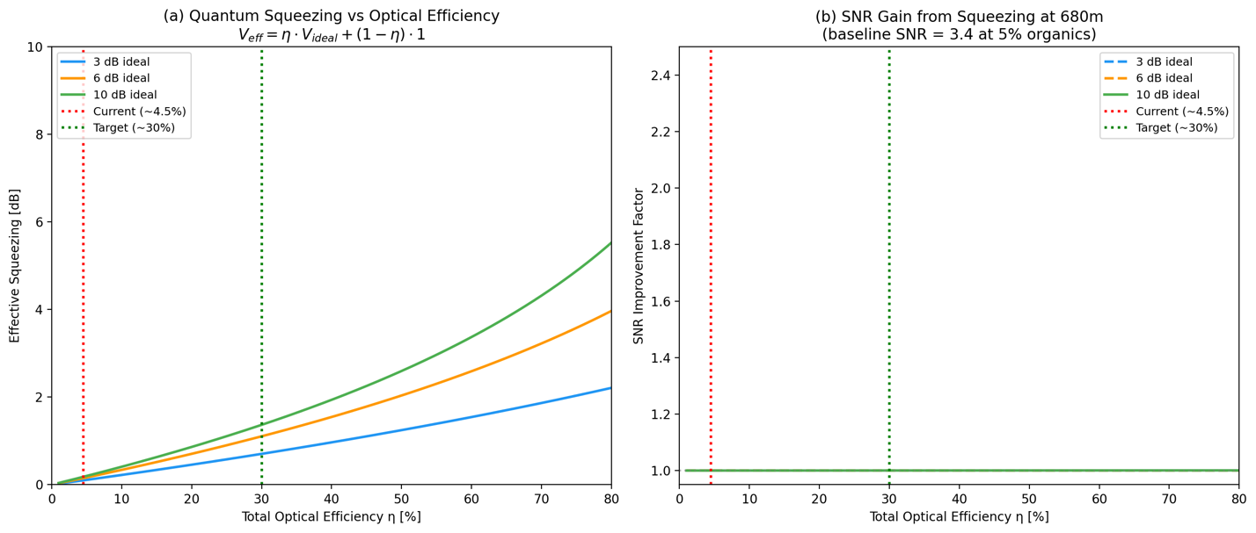[Figure 11: fig7_squeezing.png]

7. Photon Correlation Analysis
An alternative quantum-statistical approach exploits the second-order photon correlation function g⁽²⁾(τ), which measures the normalized probability of detecting photon pairs separated by delay τ (Loudon, 2000). Different sources have distinct signatures: coherent (g⁽²⁾ = 1), thermal (g⁽²⁾(0) = 2, exponential decay), and spontaneous Raman (narrow bunching peak at the vibrational coherence time ~0.1 ns).
The minimum integration for 3σ discrimination is:
T_min = 9 / (ρ⁴ · R²_total · Δτ) (6)
At Orbital B (680 m), the signal fraction ρ ≈ 0.002 and T_min ~ 10⁷ hours — clearly impractical. At close approach (200 m) with a 10× signal enhancement, sub-hour discrimination becomes achievable. Photon correlation provides a detection modality fundamentally distinct from intensity-based counting, representing a promising complementary technique for future missions.
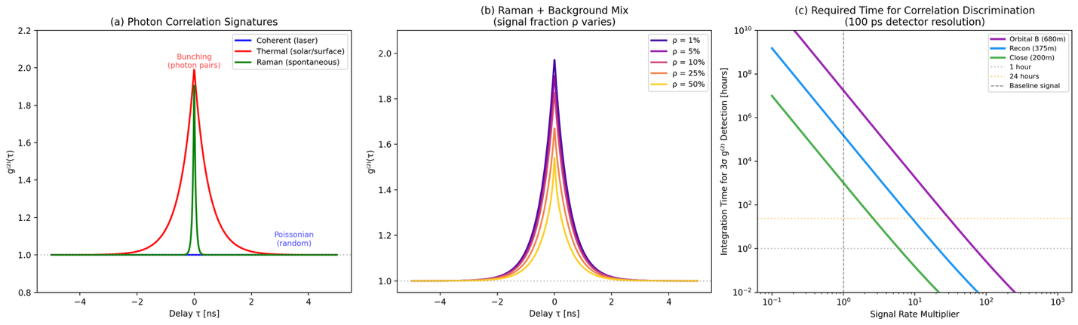[Figure 12: fig8_g2.png]

8. Discussion and Conclusions
Five conclusions emerge from this work.
First, orbital Raman detection is feasible at distances below ~500 m with the baseline DUV instrument (248 nm, 50 mJ, 30 cm, 10 s). An optimized configuration extends this to ~1200 m.
Second, 248 nm excitation provides ~200× enhancement over 532 nm through combined ν⁴ scaling and UV resonance, while eliminating fluorescence interference.
Third, organic concentration dominates detection uncertainty (ρ = 0.79), implying that target characterization is more impactful than instrument refinement.
Fourth, quantum squeezing is ineffective below ~30% optical efficiency. At the current 4.5%, 10 dB of ideal squeezing yields 0.18 dB effective — negligible.
Fifth, photon correlation offers a theoretically distinct detection pathway but requires impractical integration times at orbital distances with current technology.
The emerging field of orbital Raman for asteroid characterization is still in its early stages. The calibrated photon budget model developed here serves as a systems-level framework that connects instrument parameters, mission trajectory design, and target properties into a single decision-making tool. By inputting known parameters for other carbonaceous asteroids — Ryugu, Phaethon, or future survey targets — this framework can rapidly assess detection feasibility and inform trade studies for next-generation asteroid rendezvous missions. An open-source implementation, including an interactive web simulator, accompanies this paper.

References
Abbey, W. J., Bhartia, R., Beegle, L. W., et al. (2017). Deep UV Raman spectroscopy for planetary exploration: The search for in situ organics. Icarus, 290, 201–214. https://doi.org/10.1016/j.icarus.2017.01.039
Acosta-Maeda, T. E., Misra, A. K., et al. (2016). Remote Raman measurements of minerals, organics, and inorganics at 430 m range. Applied Optics, 55(36), 10283–10289.
Angel, S. M., et al. (2012). Remote Raman spectroscopy for planetary exploration: A review. Applied Spectroscopy, 66(2), 137–150.
Asher, S. A. (1993). UV resonance Raman spectroscopy for analytical, physical, and biophysical chemistry. Analytical Chemistry, 65(4), 59A–66A.
Bhartia, R., Beegle, L. W., DeFlores, L., et al. (2021). Perseverance’s SHERLOC investigation. Space Science Reviews, 217, 58.
Bonal, L., et al. (2024). The thermal history of Ryugu based on Raman characterization. Icarus, 408, 115826.
Casacio, C. A., et al. (2021). Quantum-enhanced nonlinear microscopy. Nature, 594, 201–206.
Caves, C. M. (1981). Quantum-mechanical noise in an interferometer. Physical Review D, 23(8), 1693–1708.
Christensen, P. R., et al. (2018). The OSIRIS-REx OTES instrument. Space Science Reviews, 214, 87.
Corpolongo, A., et al. (2023). SHERLOC Raman mineral class detections. JGR: Planets, 128(3), e2022JE007455.
Currie, L. A. (1999). Nomenclature in evaluation of analytical methods. Analytica Chimica Acta, 391(2), 105–126.
De Andrade, R. B., et al. (2020). Quantum-enhanced stimulated Raman spectroscopy. Optica, 7(5), 470–475.
Demkowicz-Dobrzański, R., et al. (2012). The elusive Heisenberg limit. Nature Communications, 3, 1063.
Ferraro, J. R., Nakamoto, K., & Brown, C. W. (2003). Introductory Raman spectroscopy (2nd ed.). Academic Press.
Furukawa, Y., et al. (2025). Ribose and other sugars in asteroid Bennu samples. Nature Geoscience.
Gares, K. L., et al. (2016). Standoff deep UV resonance Raman. Journal of Raman Spectroscopy, 47(1), 124–141.
Glavin, D. P., et al. (2025). Abundant ammonia and nitrogen-rich organic matter in Bennu samples. Nature Astronomy, 9, 199–210.
Hamilton, V. E., et al. (2019). Hydrated minerals on asteroid Bennu. Nature Astronomy, 3, 332–340.
Herman, D. I., et al. (2025). Squeezed dual-comb spectroscopy. Science, 387, 653–658.
Kaplan, H. H., et al. (2021). Composition of organics on asteroid Bennu. Astronomy & Astrophysics, 653, L1.
Lauretta, D. S., et al. (2017). OSIRIS-REx: Sample return from asteroid Bennu. Space Science Reviews, 212, 925–984.
Lauretta, D. S., & McSween, H. Y. (Eds.). (2006). Meteorites and the early solar system II. University of Arizona Press.
Lauretta, D. S., et al. (2024). Asteroid Bennu in the laboratory. Meteoritics & Planetary Science, 59, 2453–2486.
Li, J.-Y., et al. (2021). Albedo map of asteroid Bennu. Icarus, 357, 114183.
Long, D. A. (2002). The Raman effect. Wiley.
Loudon, R. (2000). The quantum theory of light (3rd ed.). Oxford University Press.
Manceau, M., et al. (2021). Overcoming detection loss in squeezing-based sensing. npj Quantum Information, 7, 169.
Maurice, S., et al. (2021). The SuperCam instrument suite. Space Science Reviews, 217(3), 47.
Misra, A. K., et al. (2012). Single-pulse standoff Raman detection at 120 m. Applied Spectroscopy, 66(11), 1279–1285.
Pizzarello, S., & Shock, E. (2010). Organic composition of carbonaceous meteorites. Cold Spring Harbor Perspectives in Biology, 2(3), a002105.
Razzell Hollis, J., et al. (2023). DUV Raman spectral library for SHERLOC. Astrobiology, 23(1), 1–23.
Rull, F., et al. (2017). The ExoMars Raman Laser Spectrometer. Astrobiology, 17, 627–654.
Sandford, S. A., et al. (2025). N- and O-rich organic material on Bennu’s parent body. Nature Astronomy, 9, 1803–1811.
Sharma, S., et al. (2023). Diverse organic-mineral associations in Jezero crater. Nature, 619, 724–732.
Simon, A. A., et al. (2020). Widespread carbon-bearing materials on asteroid Bennu. Science, 370, eabc3522.
Thompson, D. R., et al. (2020). Quantifying uncertainty for remote spectroscopy. Remote Sensing of Environment, 247, 111898.
Tse, M., et al. (2019). Quantum-enhanced advanced LIGO detectors. Physical Review Letters, 123, 231107.
Uckert, K., et al. (2021). Calibration of the SHERLOC spectrometer. Applied Spectroscopy, 75(7), 763–773.
Walls, D. F., & Milburn, G. J. (2008). Quantum optics (2nd ed.). Springer.
Wiens, R. C., et al. (2021). The SuperCam instrument suite. Space Science Reviews, 217, 4.
Zhang, J., & Shields, M. D. (2021). Modern Monte Carlo methods for UQ. WIREs Computational Statistics, 13(5), e1539.

Appendix A. Space Environment Model
The environment factor f_env in Equation (2) combines four effects. Solar incidence angle contributes cos(θ_inc), where θ_inc is drawn from a distribution centered at 45° with standard deviation 25° (clipped to [0°, 85°]). Surface roughness contributes a factor drawn from N(0.8, 0.1), clipped to [0.6, 1.0], representing 10–30% signal loss. A shadow mask randomly occludes 10% of surface points. Dust accumulation contributes a factor 1 − 0.001 · (day/365), which is 0.997 at day 100. The combined factor is f_env = cos(θ_inc) · f_rough · f_illum · f_dust, with a floor of 0.1 for illuminated points.

Appendix B. K_R Parameterization
The Raman backscatter coefficient K_R^(1%,532) = 10⁻¹¹ sr⁻¹ m⁻² corresponds to a surface with 1% organic content at 532 nm excitation. This is a lumped parameter that combines three physical quantities: the intrinsic differential Raman cross-section (dσ/dΩ), the surface molecular number density (ρ_s), and the effective laser sampling depth (δ). Explicitly, K_R ∝ (dσ/dΩ) · ρ_s · δ. The baseline value is derived using typical surface molecular densities (~10¹⁹ m⁻²), differential cross-sections (~10⁻³⁰ cm² sr⁻¹ molecule⁻¹ at 532 nm; Asher, 1993), and an effective sampling depth of ~1 μm.
To assess which component of K_R contributes most to the overall uncertainty, the analysis considers plausible variations in each. Varying the effective sampling depth from 0.5 μm to 2 μm shifts K_R by a factor of 4 (±2×). Varying the Raman cross-section by a factor of 2 shifts K_R by 2×. In contrast, varying the organic concentration from 1% to 15% shifts K_R by 15×. This confirms that organic concentration dominates the K_R uncertainty budget by a wide margin, consistent with the Monte Carlo sensitivity analysis in Section 5.

